Smart sorting transfer learning for identifying rotten fruits and vegetables- Comprehensive Project
Document

Executive Summary
This document provides a comprehensive overview of the Smart Sorting Transfer Learning System, an AI-powered solution designed for the accurate and efficient identification of fresh and rotten fruits and vegetables. By leveraging advanced deep learning techniques—particularly transfer learning with pre-trained Convolutional Neural Networks (CNNs)—the system aims to address the critical need for automated quality inspection in agricultural supply chains and retail environments.
This report consolidates insights from multiple project components, including the problem definition, solution ideation, functional and non-functional requirements, technical architecture, customer journey mapping, and implementation planning. Together, these elements present a complete and structured view of the project, outlining its journey from initial concept to scalable deployment for real-world food quality management.

Project Overview

The Smart Sorting Transfer Learning System is a web-based application developed to assist farmers, quality inspectors, retailers, and supply chain managers in the analysis of fruit and vegetable images. The core objective of the project is to provide a reliable, scalable, and user-friendly solution that reduces manual inspection workload, minimizes human error, and accelerates the sorting and quality assessment process traditionally performed through visual examination. Additionally, the system can serve as an educational and research tool for agricultural studies and food technology training, promoting awareness of AI-driven solutions in sustainable food management.

Project Details
Field
Value
Date
29
jan
2026
Team ID

LTVIP2026TMIDS83701
Project Name
smart sorting transfer learning for identifying rotten fruits and vegetables problem statement
Maximum Marks
4
Marks

Problem Definition

Core Problem
The accurate identification and classification of fresh and rotten fruits and vegetables are essential for maintaining food quality, ensuring consumer safety, and reducing food waste. However, traditional manual inspection methods are time-consuming, labor-intensive, and highly dependent on human judgment. Factors such as fatigue, inconsistent evaluation standards, and varying environmental conditions (lighting, background, handling) increase the likelihood of errors.
Existing automated sorting systems often lack the precision and robustness required to detect subtle spoilage patterns, discoloration, texture changes, and surface damage across different types of produce under varying imaging conditions.

3.2 Problem Validation
Evidence of this problem is widely observed in agricultural supply chains and retail markets, where significant food waste occurs due to inefficient sorting and delayed spoilage detection. The increasing number of AI-based agricultural research projects and publicly available datasets for fresh vs. rotten fruit classification further validate the need for intelligent automation in this domain.
Manual inspection not only leads to inconsistent quality control but also contributes to financial losses, customer dissatisfaction, and environmental impact due to wasted produce. Therefore, an advanced, automated smart sorting system powered by transfer learning is critically needed to improve efficiency, accuracy, and sustainability.

4. Ideation and Brainstorming
4.1 Brainstorming Key Ideas
Initial brainstorming for the Smart Sorting system focused on:
Developing a deep learning model for fruit and vegetable image classification.
Utilizing transfer learning to leverage pre-trained CNN models for improved efficiency and accuracy.
Building a web-based interface for easy accessibility across devices.
Classifying produce into key categories such as Fresh and Rotten (with future scope for multi-class categories).
Designing the system for integration into warehouse management and retail supply chain workflows.

4.2 Empathy Mapping
An empathy map was created to understand the perspectives of farmers, warehouse managers, and quality inspectors. This approach helped identify their daily challenges, such as time pressure, large volumes of produce, and the need for reliable quality decisions.
By analyzing what users think, feel, say, and do, the system was designed to be user-centric, simple to operate, and capable of delivering fast, accurate, and actionable results.

5. Solution Requirements
5.1 Functional Requirements
Functional requirements define the specific actions the Smart Sorting system must perform:
User Management:
User registration (email/social login), secure login, and password recovery.
Image Upload and Management:
Allow users to upload fruit and vegetable images (JPEG, PNG), validate file size and format, securely store images temporarily, and delete them after processing.
Freshness Classification:
Preprocess images (resizing, normalization).
Classify produce into predefined categories (e.g., Fresh, Rotten).
Provide confidence scores for predictions.
Integrate a pre-trained deep learning model using transfer learning.
Result Presentation:
Display classification results including freshness status and confidence level, optionally with visual indicators (e.g., highlighted spoilage areas). Future scope may include viewing historical inspection results.
Non-Functional Requirements
Non-functional requirements specify the quality attributes of the system:
Performance: Response time (5-10 seconds), scalability for concurrent users, and high throughput.
Security: Data privacy, secure authentication and authorization, and data encryption (HTTPS).
Usability: Intuitive and user-friendly interface, accessibility, and informative error messages.
Reliability: High uptime (99.9%), data integrity, and fault tolerance.
Maintainability: Modular architecture, high code quality, and testability.
Portability: Platform independence and use of widely supported open-source technologies.

Technical Architecture and Tech Stack

High-Level Architecture
HematoVision follows a client-server architecture. A web-based frontend interacts with a Python-based backend that hosts the machine learning model. The core components include:
- Client-Side (Web Browser): User interface (HTML, CSS, JavaScript) for image upload and result display.
- Web Application Backend (Flask): Handles user requests, manages image uploads, and orchestrates interactions with the ML model.
- Machine Learning Model (TensorFlow/Keras): The trained deep learning model responsible for blood cell classification.
- Storage: Local filesystem for temporary storage of uploaded images.

Detailed Tech Stack
Category
Technology/Tool
Purpose
Programming

Languages
Python
Backend logic, machine

learning
Web

Frameworks
Flask
Lightweight web application

backend
ML Frameworks
TensorFlow/Keras
Deep learning model

development, training,

deployment
Frontend
HTML
5
, CSS
3
, JavaScript
Structuring, styling, and

interactivity of web pages
Data Storage
Local Filesystem
Temporary storage for uploaded

images
Database

)
(
Future
SQLite/PostgreSQL
User management, historical

results, preferences
Version Control
Git
Collaborative development,

tracking changes
Dev

Environment
Jupyter Notebook, IDEs
ML model experimentation,

code development
Package

Management
pip
Managing Python dependencies

(
requirements.txt
)
Deployment
Cloud Platforms (AWS, GCP,

Azure), Gunicorn/uWSGI,

Nginx/Apache
Scalable and reliable

production environment,

serving application and static

fi
les

Machine Learning Model Details
- Architecture: Fine-tuned MobileNetV2 Convolutional Neural Network.
- Dataset: 12,500 augmented blood cell images from Kaggle.
- Training: 5 epochs, Adam optimizer, categorical cross-entropy loss.
- Accuracy: Approximately 85.3% validation accuracy.
- Model Persistence: Saved as blood_cell.h5 for deployment.

Customer Journey Map
The customer journey for Smart sorting involves several stages, primarily for pathologists and healthcare professionals:
- Sample Acquisition: Pathologist receives a fruits sample (manual, time-consuming).
- Image Capture: Pathologist captures digital images of blood cells using microscopy equipment.
- Image Upload: User uploads images to the HematoVision web application ( home.html ).
- Image Processing and Classification: The backend ( app.py ) processes the image using the ML model ( model.ipynb ).
- Result Display: Classification results are presented to the user on result.html .

Project Planning and User Stories

Product Backlog and Sprints
The project planning adheres to agile methodologies, with a product backlog organized into functional epics and user stories with estimated story points and priorities. The development is structured into sprints.

Key User Stories (Customer - Mobile User)
User

Type
Functional

Requirement

)
(
Epic
User

Story

Number
User Story /

Task
Acceptance

criteria
Priority
R
Customer

Mobile
(

user)
Registration
USN-
1
As a user, I

can register

for the

application

by entering

my email,

password,

and

con
fi
rming

my

password.
I can access

my account /

dashboard
High
S
1
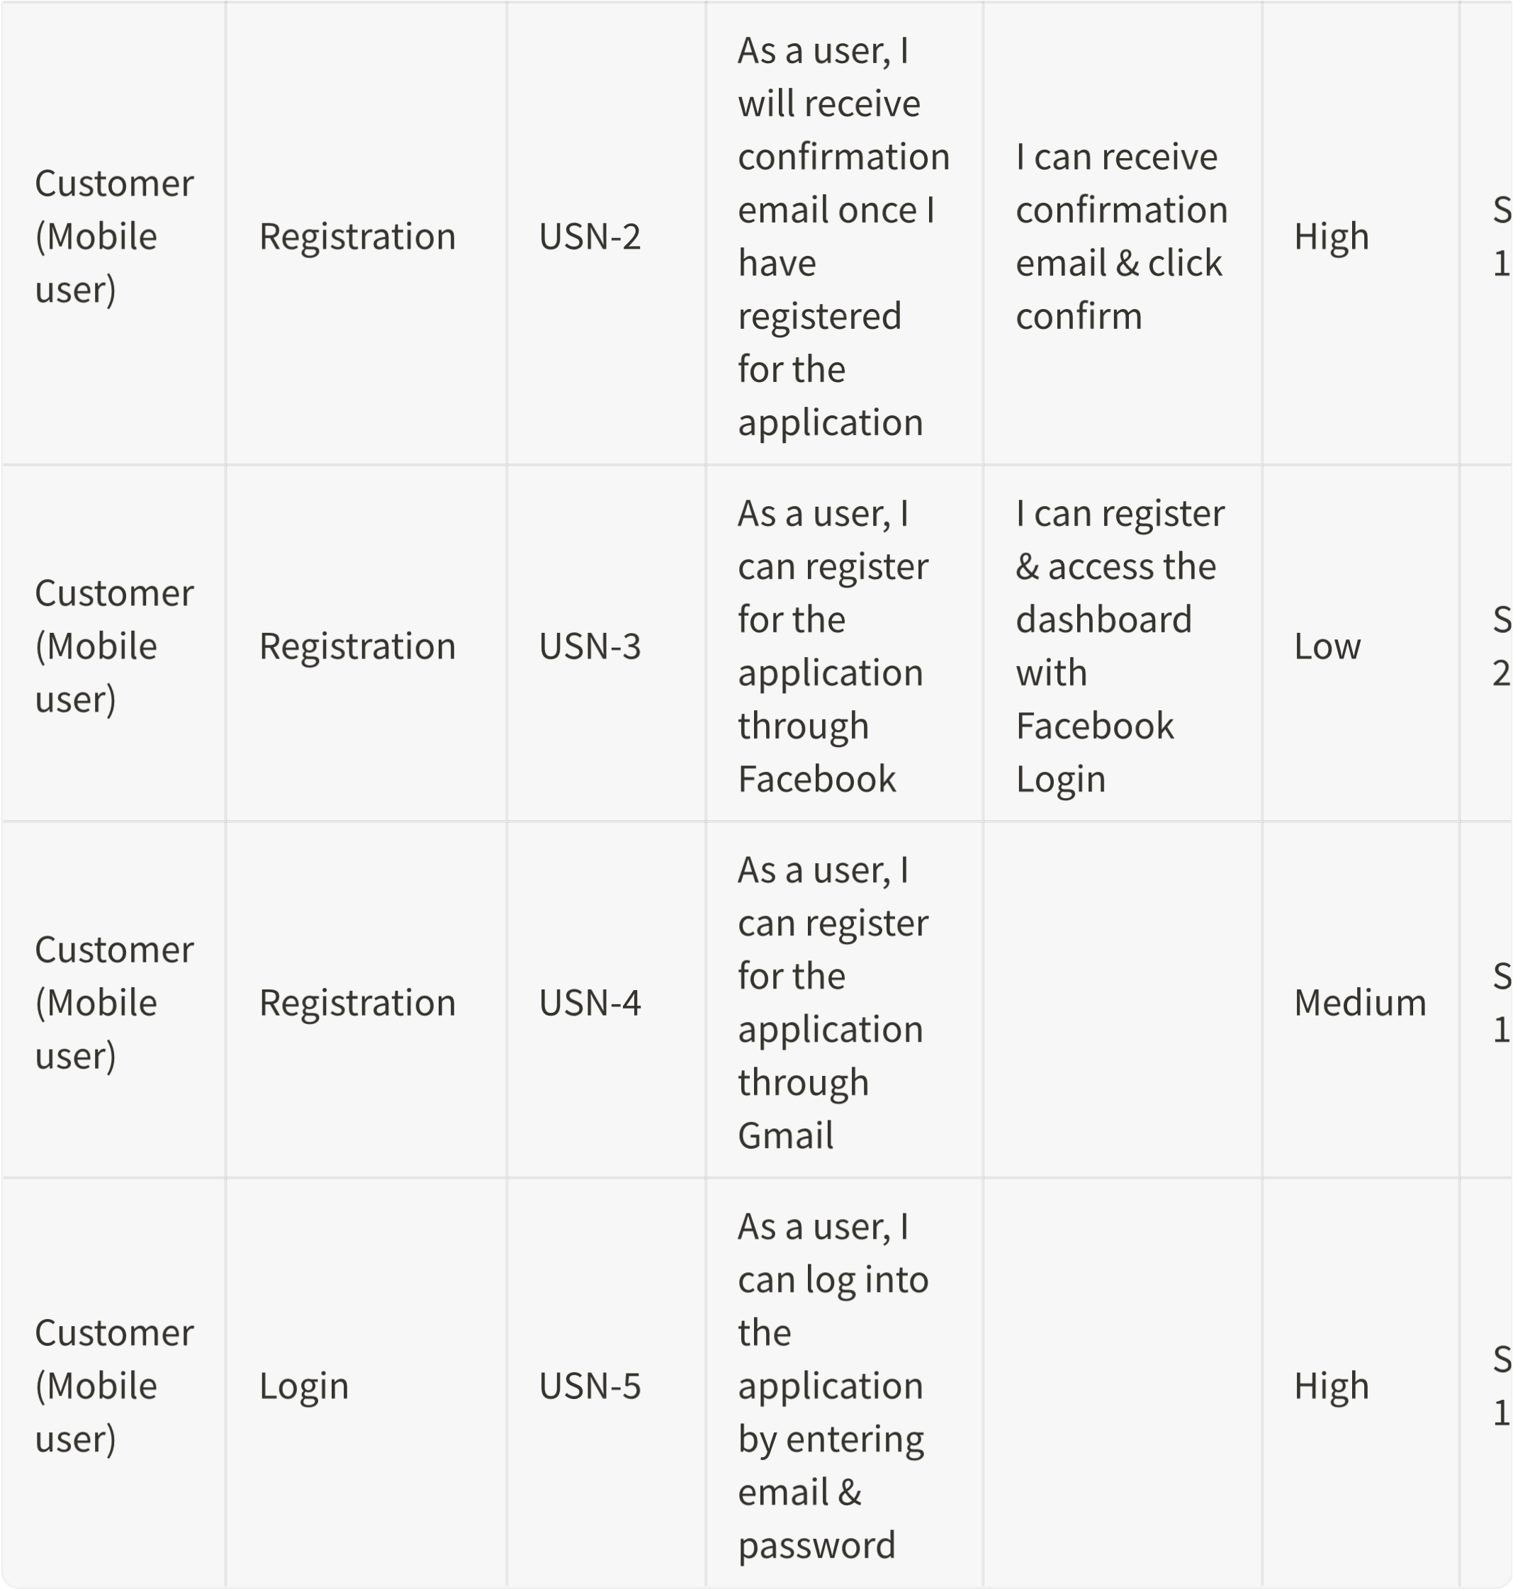

Problem-Solution Fit Analysis

Alignment
The Smart Sorting system directly addresses the core problem of inefficient and inconsistent manual inspection of fruits and vegetables by providing an automated, AI-driven alternative. It targets key pain points such as time consumption, human error, inconsistent quality checks, and dependency on manual labor.
The solution is highly desirable for farmers, warehouse managers, retailers, and food processing units as it saves time, reduces spoilage-related losses, improves operational workflow, and enhances confidence in quality control decisions.

7.2 Value Proposition Clarity
The value proposition is clear and compelling:
“Accurate and efficient freshness classification of fruits and vegetables using AI-powered transfer learning, reducing food waste and inspection time.”
Users can easily understand the benefits of faster, more consistent, and more reliable quality assessment. The system offers real-time predictions, reduced labor dependency, and improved decision-making across the supply chain.

7.3 Feasibility & Viability
Technical Feasibility
The solution is technically feasible using established deep learning techniques such as transfer learning with pre-trained CNN models (e.g., MobileNetV2, ResNet, EfficientNet) combined with a web framework like Flask or Django. Model training and deployment workflows demonstrate practical viability for real-world implementation.
Economic Viability
The system has strong economic potential by:
- Reducing labor costs associated with manual sorting
- Minimizing financial losses due to spoilage
- Improving throughput in warehouses and retail environments
- Enhancing overall supply chain efficiency
It can be monetized through subscription models, enterprise licensing, or pay-per-use services.
Risks and Assumptions
Potential risks include:
- Dataset bias affecting generalization to different produce varieties
- Variations in lighting and environmental conditions
- Integration challenges with existing warehouse systems
- Resistance to adoption from traditional operators
- Model performance degradation across diverse agricultural regions

7.4 Next Steps
Further validation and enhancement are required before large-scale deployment:
- Conduct real-world pilot testing in warehouses or retail stores
- Perform User Acceptance Testing (UAT)
- Benchmark model performance under diverse environmental conditions
- Evaluate robustness across different fruit and vegetable categories
Key Metrics to Track:
- Classification accuracy
- Prediction response time
- Reduction in food waste
- Cost savings
- User satisfaction
- Error rate reduction
Action Items:
- Expand and diversify the training dataset
- Refine and optimize the deep learning model
- Enhance features such as batch processing and analytics dashboard
- Plan scalability strategy for cloud deployment
- Develop integration APIs for supply chain systems

Conclusion
The Smart Sorting Transfer Learning System represents a significant advancement in automated fruit and vegetable quality inspection. By integrating advanced deep learning techniques with a user-friendly web interface, the project delivers a robust, efficient, and scalable solution to a critical challenge in agricultural supply chains and food retail management.
The comprehensive planning and well-structured technical architecture provide a strong foundation for real-world deployment, offering a valuable tool for farmers, warehouse managers, and retailers. By enhancing sorting accuracy, reducing food waste, and improving operational efficiency, the system contributes meaningfully to sustainable food management and modern AI-driven agricultural practices.

